Software Requirements Specifications (SRS)
IoT Gateway
Version: Draft 1.0
Date: 04-Jan-2025



319, Arth business center, Nr. Parikh hospital,
Opp. Torrent Power Station, Ring Road, Nikol, Ahmedabad Gujarat – 382350, India.
Website: www.adiinfi.co.in Email: sales@adiinfi.com

Confidentiality Notice

Copyright © 2024 Adiinfi – All rights reserved.

This document is authored by AdiInfi, and is AdiInfi, intellectual property, including the copyrights in all countries in the world. This document is provided under a license to use only with all other rights, including ownership rights, being retained by AdiInfi. This file may not be distributed, copied, or reproduced in any manner, electronic or otherwise, without the express written consent of AdiInfi.
Table of Contents
1 Document Details 3
1.1 Revision History 3
1.2 Document Approver 3
1.3 Acronyms & Abbreviation 3
1.4 Reference 3
1.5 Document Conventions 3
1.5.1 Terms Used 4
1.5.2 Requirement Marking 4
1.5.3 Note 4
1.5.4 TBD and TBR Markers 4
2 Introduction 4
2.1 Purpose 5
2.2 Scope 5
3 Scope of work 5
2 Out of Scope 5
3 System Overview 6
4 System Requirements 7
4 Interface Requirements 7
5 OTA Requirements 7
5 Operating Requirements 7
6 Functional Requirements 8
6.1.1 Functional Requirements 8
6.1.2 Non- Functional Requirements 8
7 Performance Requirements 8
8 Regulatory Compliance and Certification Requirements 9
9 External Interface Requirements 9
9.1 User Interface 9
9.2 Software Interface 9
9.3 Hardware interface 9
9.4 Communication interface 10
10 Special Implementation Notes 10
11 Software System Attributes 10
11.1 Reliability 10
11.2 Availability 10
11.3 Security 10
11.4 Maintainability 10
11.5 Portability 11
12 Acceptance Criteria 11
13 Change Management 11
14 Assumptions, Dependencies, Risks & Constraints 11
14.1 Assumptions 11
14.2 Dependencies 11
14.3 Risks 11
14.4 Known Constraints 11
15 Queries on Requirements 11

List of Figures

Figure 1: IoT Gateway Architecture Diagram 7

List of Tables
No table of figures entries found.

Document Details

  - Revision History
Version# | Date | Details of change | Author | Reviewers
Draft 0.1 | 04-Jan-25 | Draft version created | AdiInfi | Brijesh

  - Document Approver
Name | Version# | Date | Remark
Brijesh | 1.0 | 19-Jan-25 | Reviewed, Updated and Approved
  - Acronyms & Abbreviation
Sr. | Term | Description
1 | RFQ | Request For Quotation
2 | RD | Requirement Document

  - Reference
Reference Document Title | Provided by | Remarks
IoTGateway.pptx | Architecture diagram referred

  - Document Conventions
This section gives more clarity about the conventions used in this document.
    - Terms Used
Note that the force of these words is modified by the requirement level of the document in which they are used.
MUST: This word, or the terms "REQUIRED" or "SHALL", mean that the definition is an absolute requirement of the specification.
MUST NOT: This phrase, or the phrase "SHALL NOT", mean that the definition is an absolute prohibition of the specification.
SHOULD: This word, or the adjective "RECOMMENDED", mean that there may exist valid reasons in particular circumstances to ignore a particular item, but the full implications must be understood and carefully weighed before choosing a different course.
SHOULD NOT: This phrase, or the phrase "NOT RECOMMENDED" mean that there may exist valid reasons in particular circumstances when the particular behavior is acceptable or even useful, but the full implications should be understood and the case carefully weighed before implementing any behavior described with this label.
    - Requirement Marking
The use of the word “shall” indicate a requirement that must meet. Each requirement is further identified with a label in the form of SR-n where:
- SR signifies “Software Requirement”
- n is a number unique to a requirement. Each requirement is identified and tracked with this number in the all documents throughout project life cycle.
    - Note
A requirement may include an explanation of the requirement or the interaction between requirements, or other information useful in determining the intent of the requirement. The note, however, is not part of the requirement. Notes are indicated by the prefix “Note”, by verbs other than “shall,” or by enclosure in parentheses.
    - TBD and TBR Markers
‘TBD’ indicates ‘To Be Determined’ or ‘To Be Defined’ and ‘TBR’ indicated ‘To Be Revised’ requirements or parts that have yet to be fully defined. TBD indications may be used during the initial writing of the SRS, but all TBDs must be resolved and the TBD indication removed before the document is baselined and submitted for approval. <Client> will resolve all TBD markers before starting the design phase.

Introduction
An IoT Gateway is a hardware or software system that acts as a bridge between Internet of Things (IoT) devices and the cloud or central data processing systems. It facilitates communication, data processing, and management in IoT ecosystems.

Purpose
The Software Requirements Specifications (SRS) describes the detailed requirements for the software (e.g. firmware, cloud, application, BSP) design of IoT Gateway based on scope of work defined for this project. This document will be baselined and signed-off after review with AdiInfi. Once baselined and signed-off, it can be updated with changes incurred during project execution, following change management process.

Scope
The SRS includes functional and non-functional requirements of the system for software, Quality assurance and UI/UX design. These requirements form the basis for all project work. This document will be referred by software, firmware, design and test teams to develop and validate the software. The intended audience includes Managers, Engineers, Testers, and others who need to understand and implement the product functionality.

Scope of work
- Model - 1 (One Ethernet port)
  - Create Firmware with the one ethernet, SD card, RS485, Wi-Fi and Bluetooth interfaces.
  - Ethernet must have option to use Modbus or Internet functionality. Dynamic selection.
  - Implementation of OTA over internet (Wi-Fi or Ethernet), SD card, local (wireless and ethernet). OTA fallback.
  - Commissioning over Bluetooth.
  - Capture data over Modbus (Ethernet or RS485 or both) according to gateway configuration from Cloud software and send it to Cloud. In case of no internet connectivity store data to local SD card and then send it when internet available
  - Debug Logging in SD card.
  - Self-diagnostic.
  - Report status to gateway.
- Model - 2 (Two Ethernet ports)
  - All functionality of Model-1.
  - Ethernet -2 will be used for RS-485 and one for Internet or RS485
  - Machine data can be captured from each Modbus interfaces (both ethernet, and RS485)
- Out of Scope
- VPN support
- Edge processing libraries for real time processing
- Battery powered
- No device certification. Use controller’s certification like FCC, CE and UL etc

- System Overview

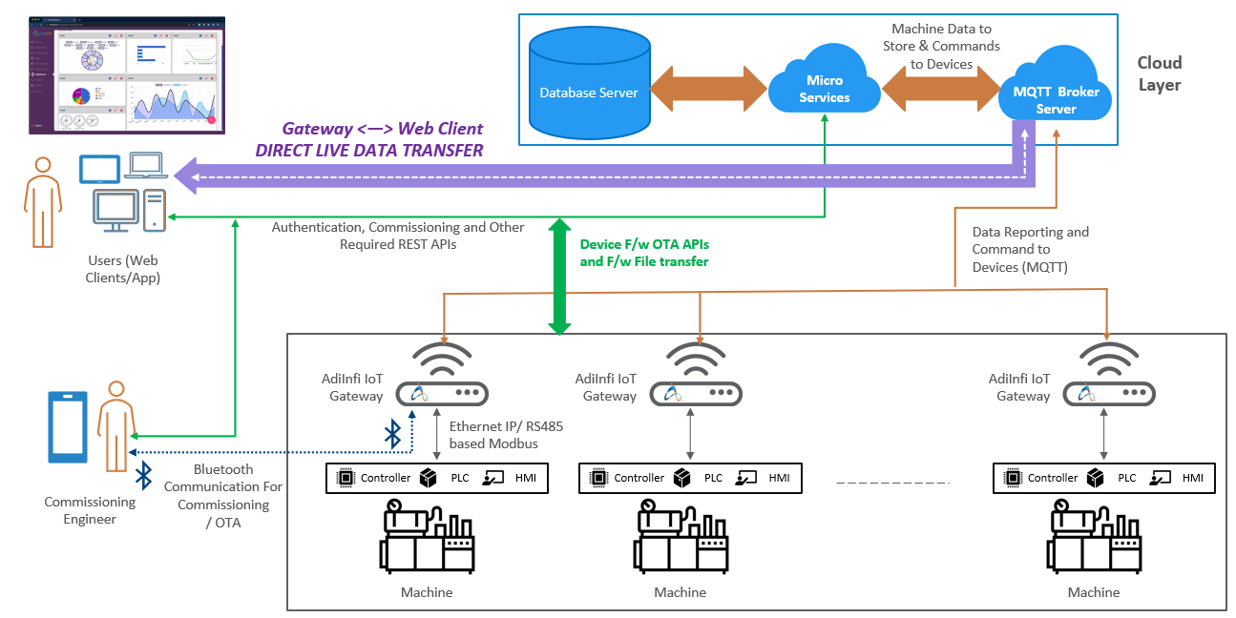

- System Requirements
Req. ID | Requirement description
SR_1 | Gateway should run on lightweight and secure operating system
SR_2 | Can use frameworks as middleware for different services like cloud integration, protocols
SR_3 | Multi-protocol support like MQTT, Ethernet/IP and Modbus. In future it will be having support of Profinet, OPC-UA, and CAN
SR_4 | Firewall and intrusion detection support, encryption libraries, secure authentication for security
SR_5 | Ensure compatibility with diverse IoT devices and sensors
SR_6 | Minimize power consumption for sustainable operation
SR_7 | Make sure SD card or internal flash is not getting written at the same spot
SR_8 | Self-diagnostics. It should test each interface, health of internal all possible components like memory, flash, SD card and report status to the cloud or mobile app
SR_9 | Debug logging with all supported different log levels
SR_10 | Unique ID generation of the device and give it to cloud as a Gateway ID. It must bot be able to change by anyone

Interface Requirements
- OTA Requirements
Req. ID | Requirement description
SR_11 | OTA using SD card. Put encrypted bin file in SD card, plug SD card in to gateway and it should self-update on reboot
SR_12 | OTA using cloud. Encrypted bin file will be received from Cloud and gateway can be updated
SR_13 | OTA using Bluetooth. Using mobile application encrypted bin file will be transferred and mobile application may initiate OTA update

Operating Requirements

Req. ID | Requirement description
SR_14 | System should consume and operate at average operating current 80 mA current @3.3V
SR_15 | System should be operating at temperature between -40° to 85°
SR_16 | Wi-fi: 802.11 b/g/n (802.11n up to 150 Mbps)
SR_17 | Connected Bluetooth device should be in range: 100 m
SR_18 | Ethernet communication using external LAN8720 or IP101
SR_19 | Exposure to water, moisture or fire may result in electrical short circuits between pins and components on the module, potentially leading to malfunction or permanent damage.

Functional Requirements

Functional Requirements
Req. ID | Requirement description
SR_20 | Only authorized person must access the system.
SR_21 | Detect the potential threat to the system.
SR_22 | Each interface communication must be secured using encryption or SSL
SR_23 | Support a wide range of communication protocols (MQTT, MODBUS, BLE, Wi-Fi).
SR_24 | Accurately collect data from sensors and connected devices without data miss.
SR_25 | The system must be always available and operational to use.
SR_26 | Handle increasing number of devices and data volume.
SR_27 | Status LED for: Device power  Each interface with separate communication LEDs with different LED blinking to show active, online, Ethernet communication, off communication tx/rx etc
SR_28 | Support for 3rd part devices on external each interface and test examples
SR_29 | 3rd party MQTT server data send
SR_30 | MQTT communication will be for data send and receive for Monitoring and Controlling application
SR_31 | Modbus, Ethernet/IP communication will be for data send and receive for Monitoring and Controlling application

Non- Functional Requirements
Req. ID | Requirement description
SR_32 | The system must recover itself in case of crash.
SR_33 | The response time between gateway and commands should be minimum.
SR_34 | Maintain the accuracy and completeness of data.
SR_35 | Efficiently use the CPU, memory and other resources.
SR_36 | The throughput of the gateway should be maximum.
SR_37 | Installing and configuring the system should be easy.
SR_38 | The system should support older devices and protocols.
SR_39 | Operating temperature: -40°C to +85 °C

Performance Requirements
Req. ID | Requirement description
SR_40 | Throughput: The maximum amount of data the gateway can handle per unit time.
SR_41 | Latency: The time delay between data generation and its arrival at cloud other destinations.
SR_42 | CPU: Sufficient processing power
SR_43 | Reliability: High uptime and resilience to network disruptions and hardware failures.
SR_44 | Connectivity: Support for various communication protocols (Wi-Fi, Bluetooth, LAN)
SR_45 | Ruggedness: Ability to withstand harsh environmental conditions (Temperature, Humidity, Vibrations).

Regulatory Compliance and Certification Requirements

Req. ID | Requirement description
NA | Out of scope

External Interface Requirements

User Interface
Req. ID | Requirement description
SR_46 | Mobile interface using mobile app for remote access
SR_47 | Console based logs at the time of debugging mode

Software Interface
Req. ID | Requirement description
SR_48 | Setting up Wi-Fi, Ethernet, Bluetooth and other network connections.
SR_49 | Monitoring gateway health, viewing logs and troubleshooting issues.
SR_50 | Automatic or manual detection of connected devices.
SR_51 | Configuring access control, encryption and other security measures.
SR_52 | Converting data into formats suitable for cloud transmission (JSON, XML).
SR_53 | Performing basic data analysis, anomaly detection or control actions locally on gateway.

Hardware interface

Req. ID | Requirement description
SR_54 | Model-1: One Ethernet for Internet or Modbus (Ethernet/IP) access
SR_55 | Model-2: Another Ethernet for Modbus access
SR_56 | RS485 for Modbus access
SR_57 | Bluetooth for commissioning and Mobile application
SR_58 | WiFi for internet access
SR_59 | All possible SPI, I2C, ADC, Digital or Analog IOs, UART, 4-20ma
SR_60 | Power: DC input from 5V to 24V  AC 100V - 230V
SR_10 | No UART debug

Communication interface
Req. ID | Requirement description
SR_61 | Support IPv4 and DNS, SSL/TLS for secure communication
SR_62 | IoT Protocols like MQTT for telemetry Rest API and WebSocket for real time updates

Special Implementation Notes
This section describes anything specific to implementation that is not explicitly covered as a requirement, but could be critical to implementation.

Software System Attributes
The following items provide a partial list of system attributes that can serve as requirements that should be objectively verified.

Reliability
- Device must be always in a operable mode and connected to the network. In case of no network or issues LED shall be visible properly
- Communication must be secure and reliable

Availability
- Create a list of components with lead time and make sure right procurement cycle is implemented for the manufacturing
- Create a demand and supply cycle with backup

Security
- Use SSL layer for cloud communication
- MQTT data must be encrypted
- In case of 3rd party MQTT data send will be as per 3rd party data in Json format
- Internal data storage will be encrypted
- Cloud communication with the OAuth2.0 authentication

Maintainability
- Code must be with proper code commenting and follow coding guideline. Add coding guide line to repository along with SRS.
- Debugging must be with log levels and support of remote debugging with different possibilities.
- Code must be modular and proper locking mechanism to operate hardware or common resources.

Portability
- Single code must be maintained with the proper compile time macros for Module-1 and Module-2.
- Each interface with the compile time macro.
- Device must be with the 30% free programming flash for future purpose.

Acceptance Criteria
- Gateway must be working with all the above-mentioned requirements.
- Each requirement’s design, implementation and test trackability matrix.

Change Management
Requirement specifications once base-lined can only be updated by adhering to change management process; whereby all changes that need to be incorporated after baseline of SRS are candidate for impact analysis i.e. change of scope and its impact on overall project will be evaluated.

Assumptions, Dependencies, Risks & Constraints
This section describes any assumptions and design constraints that are known at the time of signing-off the SRS document. These points will be tracked through implementation and may impact cost, timeline or quality of product.

Assumptions

Dependencies
- Hardware components

Risks
- Program size as per current 4MB of hardware controller selection

Known Constraints

Queries on Requirements
Maintain all queries & the responses in this section. This will be helpful at the later stage of project.
Embed query tracking spreadsheet here to capture queries of requirements.
<Embed QTS from AdiInfi templates>

